Lab Experiments

1.Code:
import random

GOAL = [1,2,3,4,5,6,7,8,0] # 0 is the empty space

def print_board(b):
for i in range(0,9,3):
print(' '.join(' ' if x==0 else str(x) for x in b[i:i+3]))
print()

def inversions(arr):
a = [x for x in arr if x!=0]
inv = 0
for i in range(len(a)):
for j in range(i+1,len(a)):
if a[i] > a[j]:
inv += 1
return inv

def is_solvable(arr):
return inversions(arr) % 2 == 0

def scramble():
while True:
b = GOAL[:]
random.shuffle(b)
if is_solvable(b) and b != GOAL:
return b

def neighbors(idx):
r, c = divmod(idx, 3)
res = []
for dr,dc in [(-1,0),(1,0),(0,-1),(0,1)]:
nr, nc = r+dr, c+dc
if 0 <= nr < 3 and 0 <= nc < 3:
res.append(nr*3 + nc)
return res

def play():
board = scramble()
print("8-Puzzle — slide tiles to reach:")
print_board(GOAL)
steps = 0
while True:
print("Current board:")
print_board(board)
if board == GOAL:
print(f"Solved in {steps} moves — well done!")
break
cmd = input("Enter tile number to move (or 'q' to quit): ").strip()
if cmd.lower() == 'q':
print("Quitting. Bye!")
break
if not cmd.isdigit():
print("Please enter a number 1-8.")
continue
tile = int(cmd)
if tile < 1 or tile > 8:
print("Choose a tile between 1 and 8.")
continue
try:
t_idx = board.index(tile)
z_idx = board.index(0)
except ValueError:
print("Tile not found — unexpected error.")
continue
if t_idx in neighbors(z_idx):
board[z_idx], board[t_idx] = board[t_idx], board[z_idx]
steps += 1
else:
print("That tile can't move into the empty space. Choose an adjacent tile.")

if __name__ == "__main__":
play()
Output: 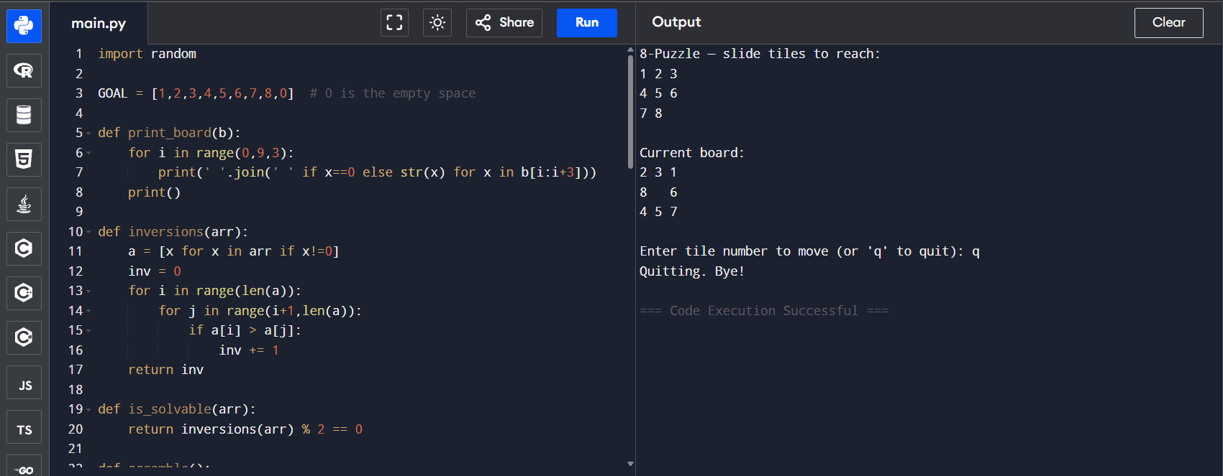

2.Code:
def hanoi(n, source, helper, target):
if n == 1:
print("Move disk 1 from", source, "to", target)
return
hanoi(n-1, source, target, helper)
print("Move disk", n, "from", source, "to", target)
hanoi(n-1, helper, source, target)

n = int(input("Enter number of disks: "))
print("Steps to solve Towers of Hanoi:")
hanoi(n, 'A', 'B', 'C')

Output:
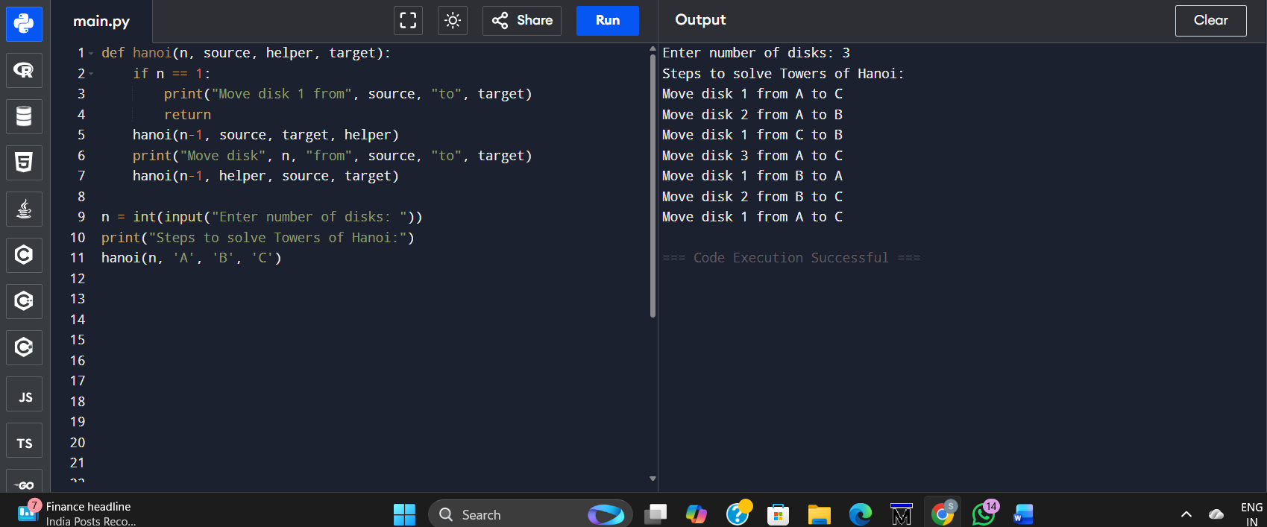

3.Code:
from collections import deque

def bfs(graph, start):
visited = set()
queue = deque([start])

while queue:
node = queue.popleft()
if node not in visited:
print(node, end=" ")
visited.add(node)
for neigh in graph[node]:
if neigh not in visited:
queue.append(neigh)

graph = {
'A': ['B', 'C'],
'B': ['D', 'E'],
'C': ['F'],
'D': [],
'E': ['F'],
'F': []
}

start_node = 'A'
print("BFS Traversal:")
bfs(graph, start_node)
Output:
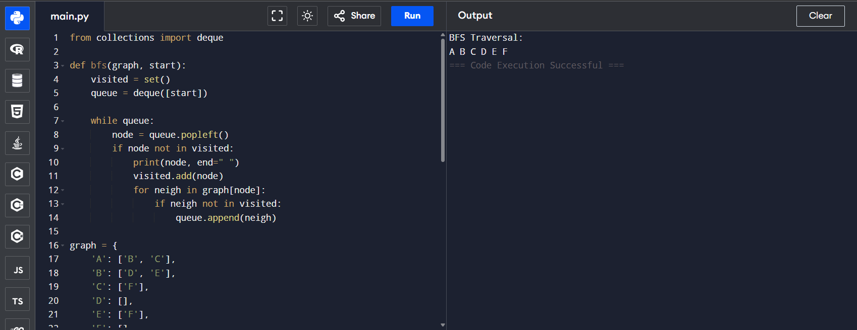

4.Code:
def monkey_problem():
state = {
"monkey": "door",
"box": "window",
"monkey_on_box": False,
"has_banana": False
}

print("Initial State:", state)

state["monkey"] = "middle"
print("Monkey moves to middle:", state)

state["box"] = "middle"
print("Monkey pushes box to middle:", state)

state["monkey_on_box"] = True
print("Monkey climbs on box:", state)

state["has_banana"] = True
print("Monkey takes banana:", state)

print("\nFinal State:", state)

monkey_problem()
Output :
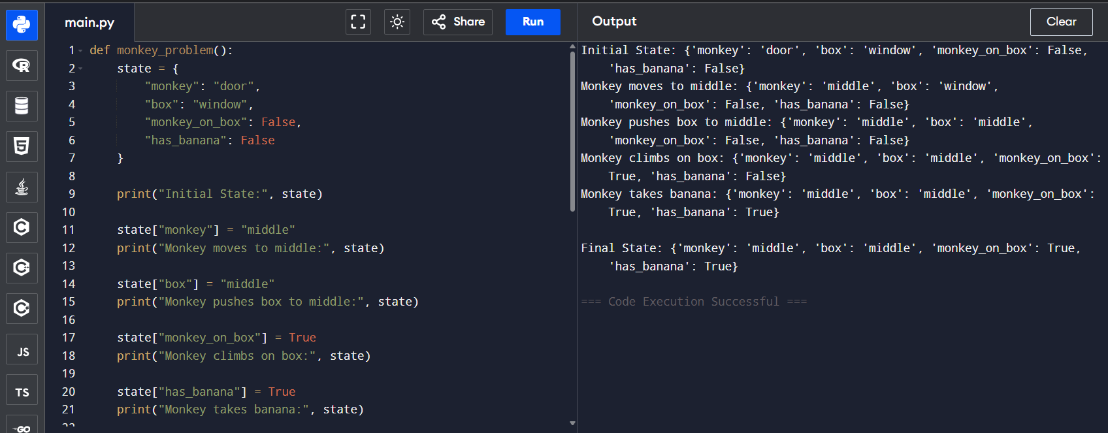

5.Code :
def solve_n_queens(n=8):
solutions = []
def backtrack(row, cols, diag1, diag2, pos):
if row == n:
solutions.append(pos[:])
return
for col in range(n):
if col in cols or (row-col) in diag1 or (row+col) in diag2:
continue
cols.add(col); diag1.add(row-col); diag2.add(row+col)
pos.append(col)
backtrack(row+1, cols, diag1, diag2, pos)
pos.pop()
cols.remove(col); diag1.remove(row-col); diag2.remove(row+col)

backtrack(0, set(), set(), set(), [])
return solutions

def print_board(solution):
n = len(solution)
for r in range(n):
row = ['.'] * n
row[solution[r]] = 'Q'
print(' '.join(row))
print()

if __name__ == "__main__":
sols = solve_n_queens(8)
print("Number of solutions:", len(sols))
for i, sol in enumerate(sols, 1):
print("Solution", i)
print_board(sol)
Output:
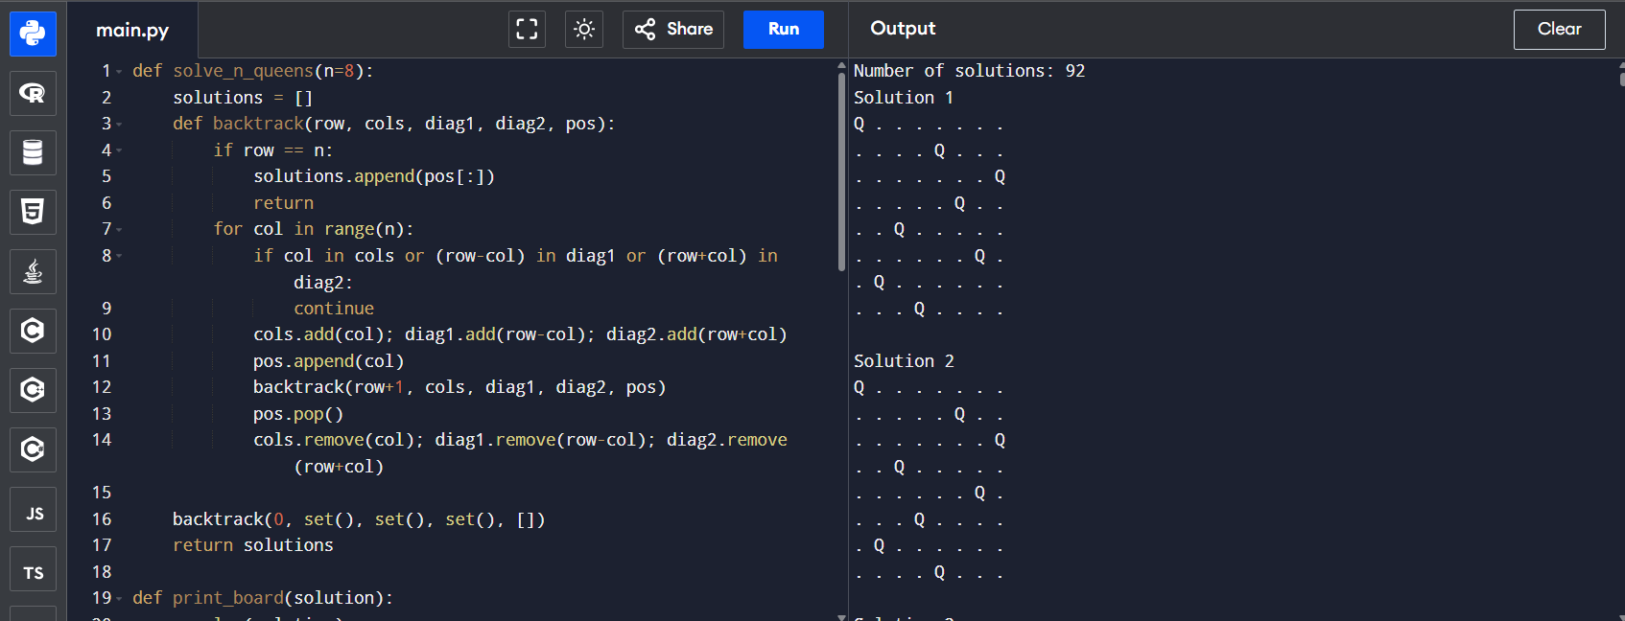

6.Code:
def dfs(graph, start, visited=None):
if visited is None:
visited = set()
print(start, end=" ")
visited.add(start)

for neigh in graph[start]:
if neigh not in visited:
dfs(graph, neigh, visited)

graph = {
'A': ['B', 'C'],
'B': ['D', 'E'],
'C': ['F'],
'D': [],
'E': ['F'],
'F': []
}

print("DFS Traversal:")
dfs(graph, 'A')
Output:
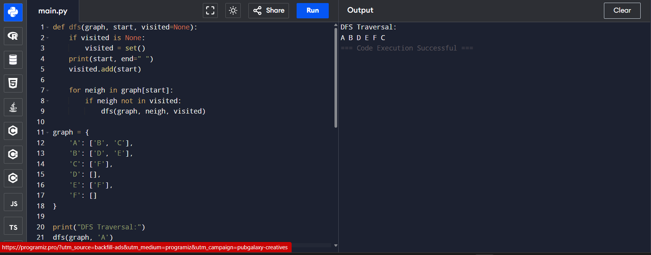

7.Code
from collections import deque

def bfs_solve(capA, capB, target):
start = (0, 0)
q = deque([start])
visited = {start}
parent = {start: None}
action = {start: "Start"}

while q:
a, b = q.popleft()
if a == target:
path = []
cur = (a, b)
while cur is not None:
path.append((cur, action[cur]))
cur = parent[cur]
return list(reversed(path))
next_states = []
# fill A
next_states.append(((capA, b), f"Fill {capA}-gallon (A)"))
# fill B
next_states.append(((a, capB), f"Fill {capB}-gallon (B)"))
# empty A
next_states.append(((0, b), "Empty A"))
# empty B
next_states.append(((a, 0), "Empty B"))
# pour A -> B
transfer = min(a, capB - b)
next_states.append(((a - transfer, b + transfer), f"Pour A -> B ({transfer} gal)"))
# pour B -> A
transfer = min(b, capA - a)
next_states.append(((a + transfer, b - transfer), f"Pour B -> A ({transfer} gal)"))

for nxt, act in next_states:
if nxt not in visited:
visited.add(nxt)
parent[nxt] = (a, b)
action[nxt] = act
q.append(nxt)
return None

if __name__ == "__main__":
capA, capB = 4, 3
target = 2
solution = bfs_solve(capA, capB, target)
if solution:
print("Steps to get", target, "gallons in the 4-gallon jug:\n")
for i, ((a, b), act) in enumerate(solution):
print(f"Step {i}: State A={a}, B={b} <-- {act}")
else:
print("No solution found.")
